

# 

## 

### 

{"height":{"meters":70,"feet":229.6},"diameter":{"meters":3.7,"feet":12},"mass":{"kg":549054,"lb":1207920},"first_stage":{"thrust_sea_level":{"kN":7607,"lbf":1710000},"thrust_vacuum":{"kN":8227,"lbf":1849500},"reusable":true,"engines":9,"fuel_amount_tons":385,"burn_time_sec":162},"second_stage":{"thrust":{"kN":934,"lbf":210000},"payloads":{"composite_fairing":{"height":{"meters":13.1,"feet":43},"diameter":{"meters":5.2,"feet":17.1}},"option_1":"dragon"},"reusable":false,"engines":1,"fuel_amount_tons":90,"burn_time_sec":397},"engines":{"isp":{"sea_level":288,"vacuum":312},"thrust_sea_level":{"kN":845,"lbf":190000},"thrust_vacuum":{"kN":914,"lbf":205500},"number":9,"type":"merlin","version":"1D+","layout":"octaweb","engine_loss_max":2,"propellant_1":"liquid oxygen","propellant_2":"RP-1 kerosene","thrust_to_weight":180.1},"landing_legs":{"number":4,"material":"carbon fiber"},"payload_weights":[{"id":"leo","name":"Low Earth Orbit","kg":22800,"lb":50265},{"id":"gto","name":"Geosynchronous Transfer Orbit","kg":8300,"lb":18300},{"id":"mars","name":"Mars Orbit","kg":4020,"lb":8860}],"flickr_images":["https:\/\/farm1.staticflickr.com\/929\/28787338307_3453a11a77_b.jpg","https:\/\/farm4.staticflickr.com\/3955\/32915197674_eee74d81bb_b.jpg","https:\/\/farm1.staticflickr.com\/293\/32312415025_6841e30bf1_b.jpg","https:\/\/farm1.staticflickr.com\/623\/23660653516_5b6cb301d1_b.jpg","https:\/\/farm6.staticflickr.com\/5518\/31579784413_d853331601_b.jpg","https:\/\/farm1.staticflickr.com\/745\/32394687645_a9c54a34ef_b.jpg"],"name":"Falcon 9","type":"rocket","active":true,"stages":2,"boosters":0,"cost_per_launch":50000000,"success_rate_pct":98,"first_flight":"2010-06-04","country":"United States","company":"SpaceX","wikipedia":"https:\/\/en.wikipedia.org\/wiki\/Falcon_9","description":"Falcon 9 is a two-stage rocket designed and manufactured by SpaceX for the reliable and safe transport of satellites and the Dragon spacecraft into orbit.","id":"5e9d0d95eda69973a809d1ec"}

### 

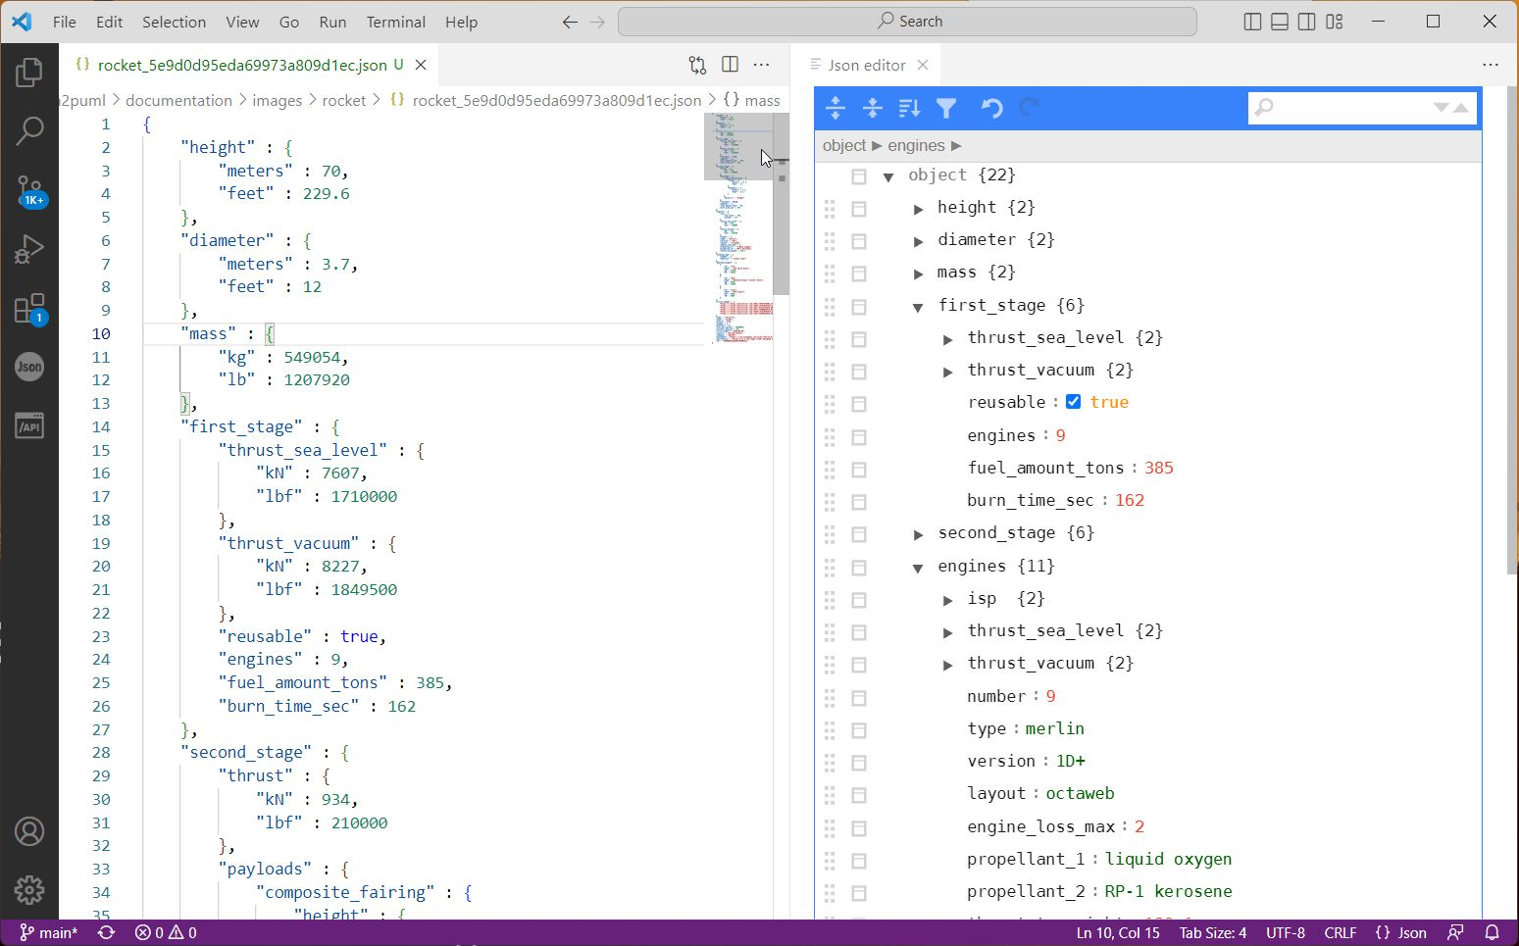

☺

### 

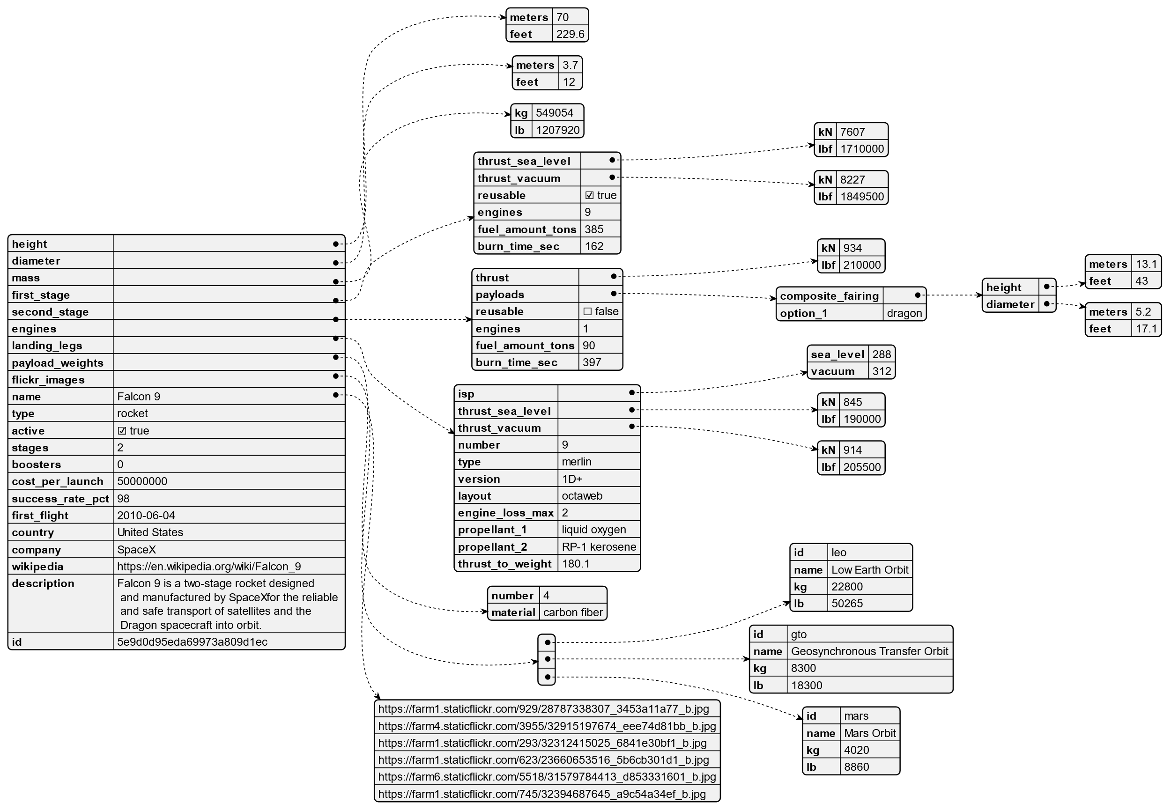

## 

## 

SpaceX REST API

**Open-Source REST API for launch, rocket, core, capsule, starlink, launchpad, and landing pad data.**

[https://github.com/r-spacex/SpaceX-API](https://swapi.dev/)

What is this?

It’s an unofficial public API to receive various information about all Space X rocket launches.

### 

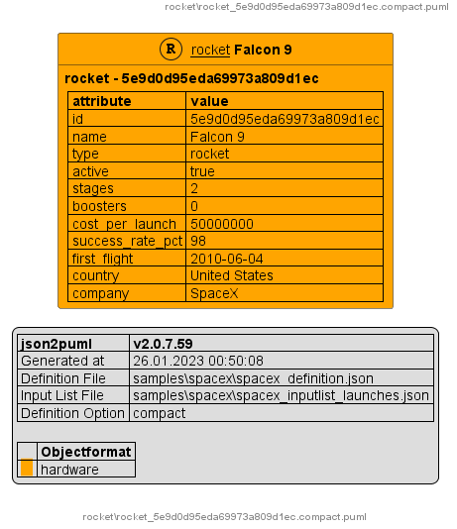

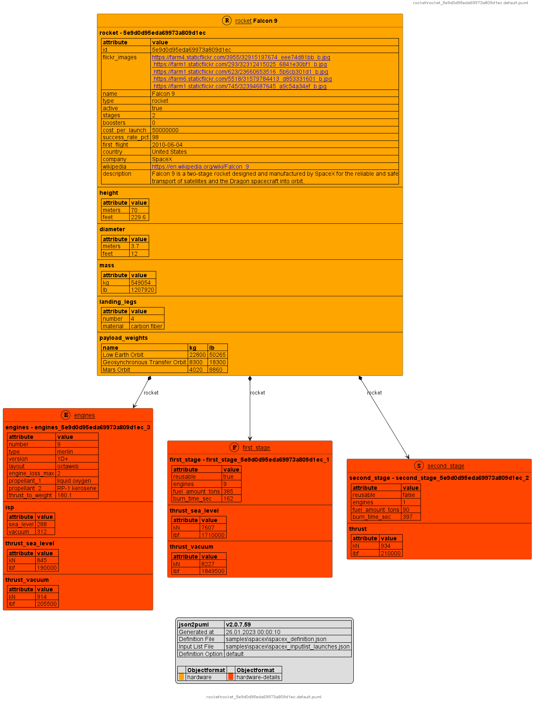

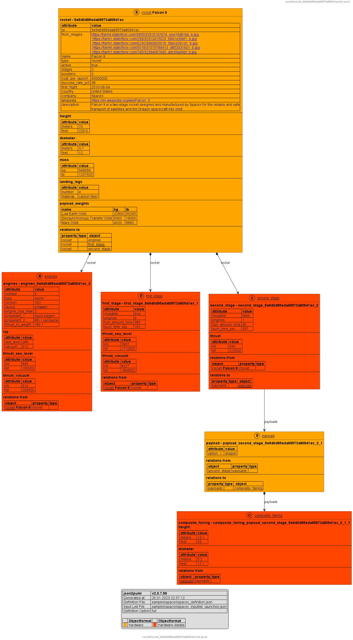

### 

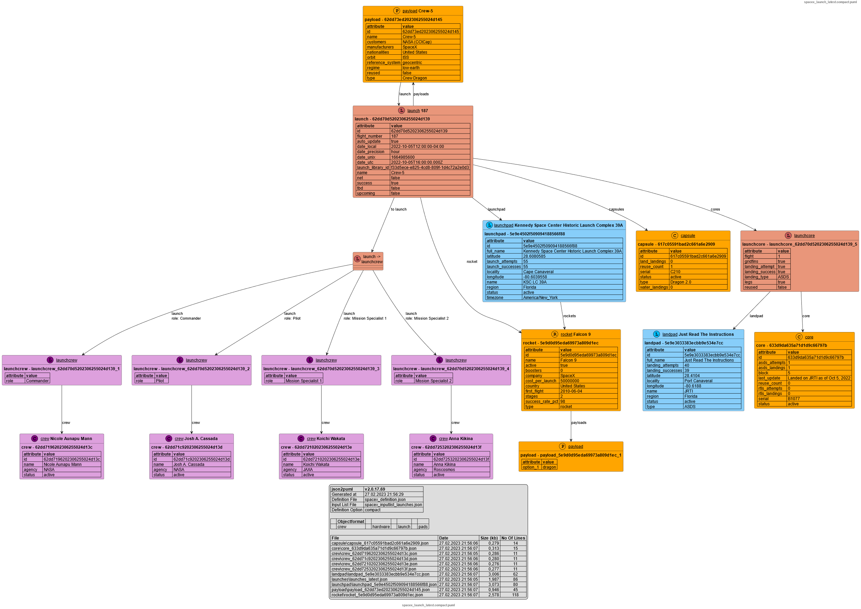

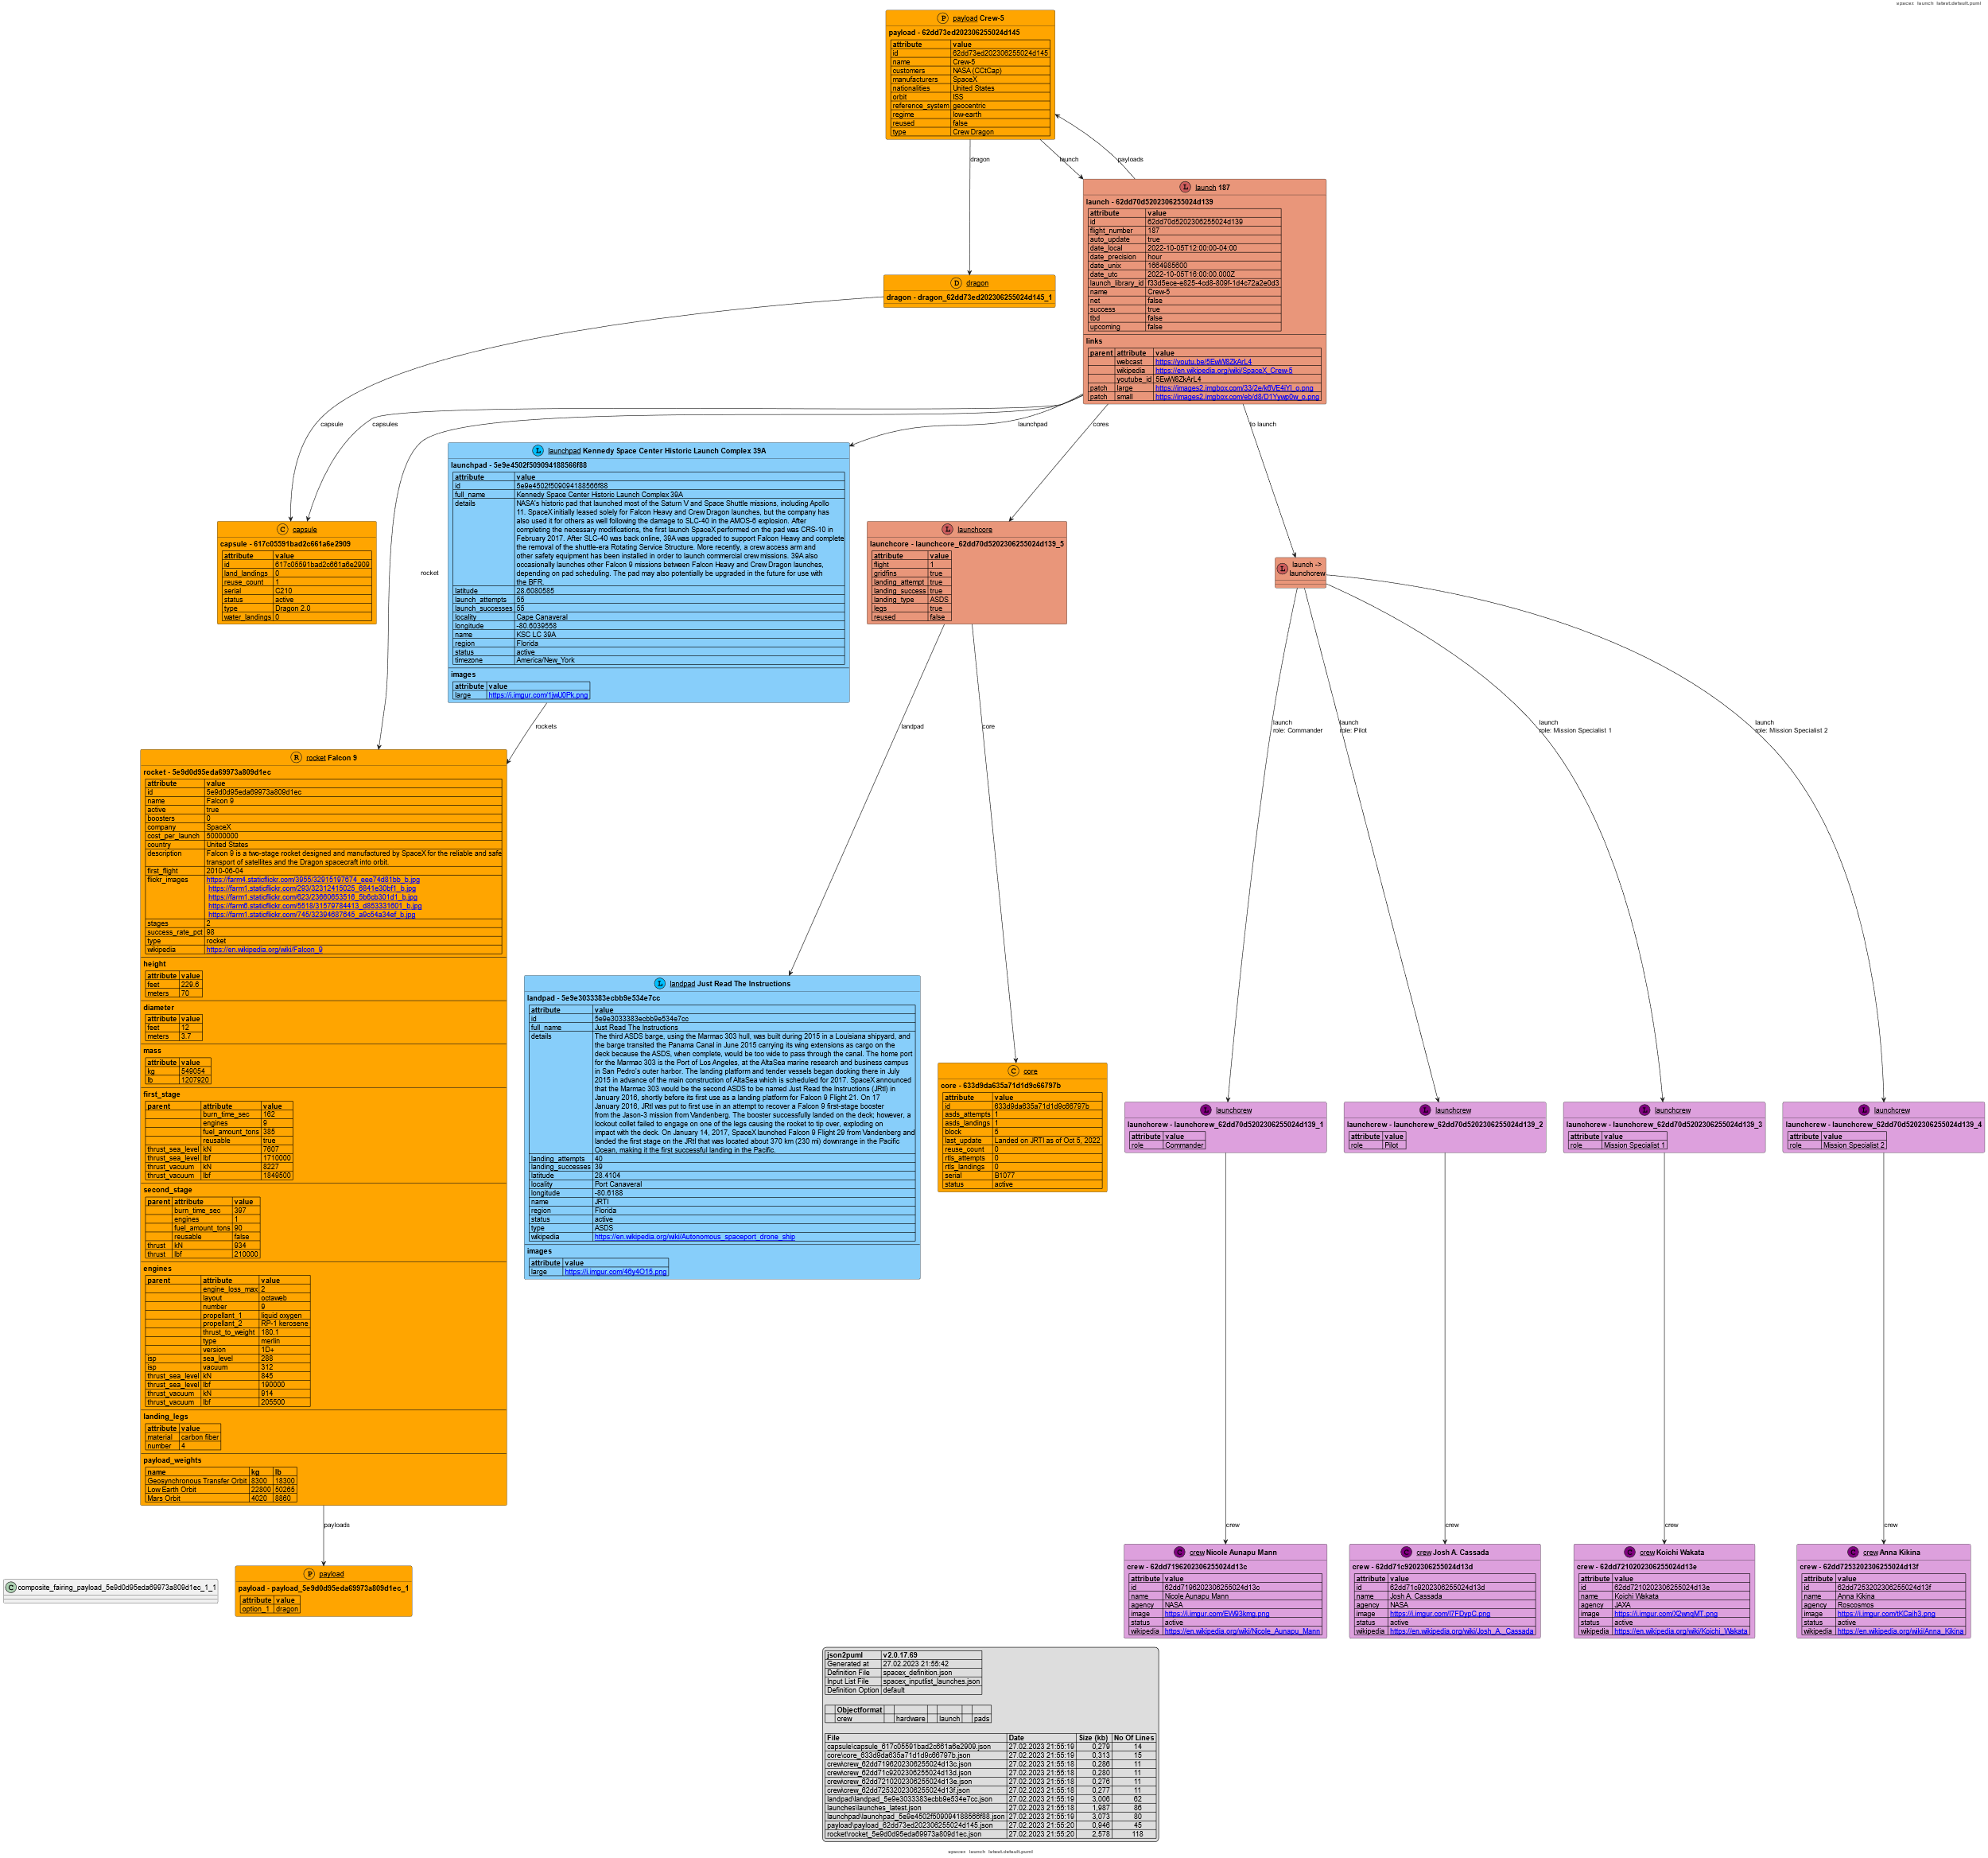

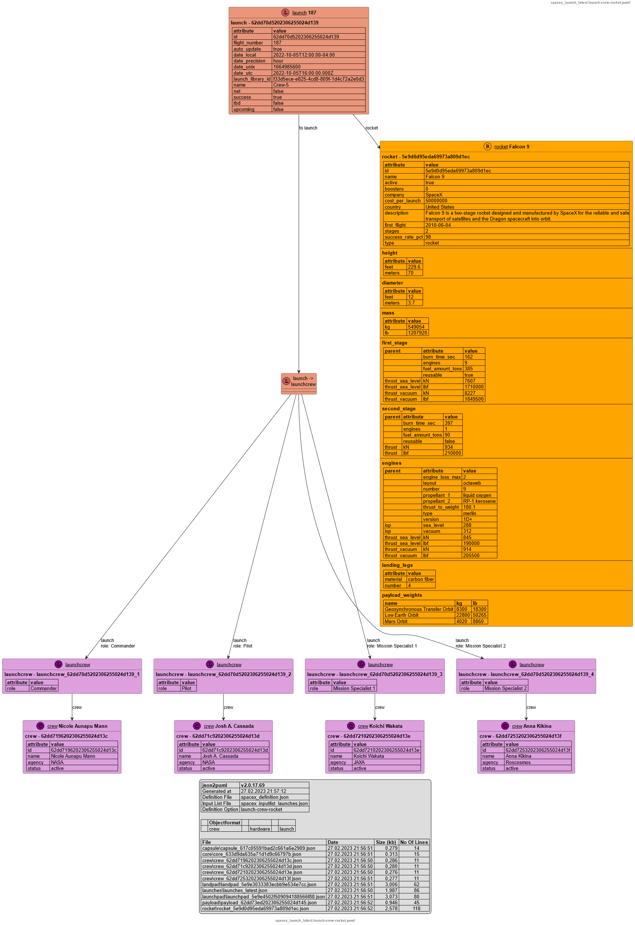

## 

[SWAPI - The Star Wars API](https://swapi.dev/)

<https://swapi.dev/>

What is this?

The Star Wars API, or "swapi" (Swah-pee) is the world's first quantified and programmatically-accessible data source for all the data from the Star Wars canon universe!

We've taken all the rich contextual stuff from the universe and formatted into something easier to consume with software. Then we went and stuck an API on the front so you can access it all!

### 



 

        
        
        
     
     

        
        
        
     
     

 



        
        
        
     
     

        
        
        
     
     

 

 